**UCS503 Software Engineering Lab**

Destination Dose (Tourism Website)

**UCS 503 Software Engineering Project Report**

**Mid-Semester Evaluation**

**Submitted by:**

**(102217093) PRAJWOL REGMI**

**(102217069) DIVYANSHU KUMAR**

**(102217075) AKSHIT TIWARI**

**(102217054) NAMRAH SHARMA**

**BE Second Year- CSE**

**Group No: 03**

Submitted to : **DR. RITU GOTHWAL**

Name of the Faculty : **DR. HIMIKA SHARMA**



**Computer Science and Engineering Department**

**TIET, Patiala**

**April 2024**

**UCS503- Software Engineering Lab**

**TABLE OF CONTENTS**

**S.No.** **Assignment** **Page No.**

1. **Project Selection Phase**

1.1 Software Bid

1.2 Project Overview

1. **Analysis Phase**

2.1 Use Cases

2.1.1 Use-Case Diagrams

2.1.2 Use Case Templates

2.2 Activity Diagram and Swimlane Diagrams

2.3 Class Diagram

2.4 Data Flow Diagrams (DFDs)

2.4.1 DFD Level 0

2.4.2 DFD Level 1

2.4.2 DFD Level 2

2.5 Software Requirement Specification in IEEE Format

2.6 User Stories and Story Cards

**1.Project Selection Phase**

**1.1** **Software Bid/Project Team**

**UCS503-Software Engineering Lab**

**Group: 2CS3 Dated: 4th Feb 2024**

**Team Name:** NEXA

**Team ID:** 03

|  |  |  |  |  |
| --- | --- | --- | --- | --- |
| **Name** | Roll No. | Project Experience | Programming Language used | Signature |
| Prajwol Regmi | 102217093 | N/A | N/A |  |
| Akshit Tiwari | 102217075 | N/A | N/A |  |
| Namrah Sharma | 102217054 | N/A | N/A |  |
| Divyanshu Kumar  (Leader) | 102217069 | N/A | N/A |  |

**Programming Language/Environment Experience**

List the languages you are most comfortable developing in, as a team, in your order of preference. Many of the projects involve Java or C/C++ programming.

1. HTML 4. PHP
2. CSS 5. JAVASCRIPT
3. Django 6. MongoDB/SQL

**Choices of Projects:**

Please select 4 projects your team would like to work on, by order of preference: *[Write at-least one paragraph for each choice (motivation, reason for choice, feasibility analysis, etc.)]*

|  |  |  |
| --- | --- | --- |
| **Choices** | **Project Name** | **USP** |
| First Choice | Destination Dose (Tourism Website) | Comprehensive Travel Experiences, Exclusive Offers,  Community of Explorers |
| Second Choice | MuseMentor(Instrument Learning Website) | Personalized Progress Paths, Lifetime Learning Assurance, Diverse Learning Ecosystem |
| Third Choice | Wander Wisdom (Blog Website) | Community Building, Personal Branding, Real-Time Updates |
| Fourth Choice | Woof Wellness(Pet Care Website) | Pet Adoption Platform, Expert Vet Advice, Compasinate Services |

# Additional Remarks/ Inputs

Please tell us about any other factors that we should take into consideration (e.g., if you really would like to work on a project for some particularly convincing reason).

When creating a tourist website for city exploration, prioritize cultural respect, safety, and sustainability.

………………………………………………………………………………………………

Optimize for mobile and multilingual accessibility, while ensuring data privacy and community

………………………………………………………………………………………………

engagement.

………………………………………………………………………………………………

**1.2 Project Overview**

Destination Dose aims to eliminate such problems with a one stop solution to all your travel needs starting as basic as where is the best grocery store for your daily needs near you, to where you can find the best dining options around you. We at Destination Dose ensure your safety at all times, all suggestions are ensured to be completely safe, a warning will also be shown for places that are not too safe to visit around the city. We will also provide personalized plans according to the time you can spare. With Destination Dose, no plan will ever turn out bad ever again. All expenses will be shown beforehand, so you can plan a hassle-free outing with your loved ones.

**2.Analysis Phase**

**2.1.1 Use Case Diagram**

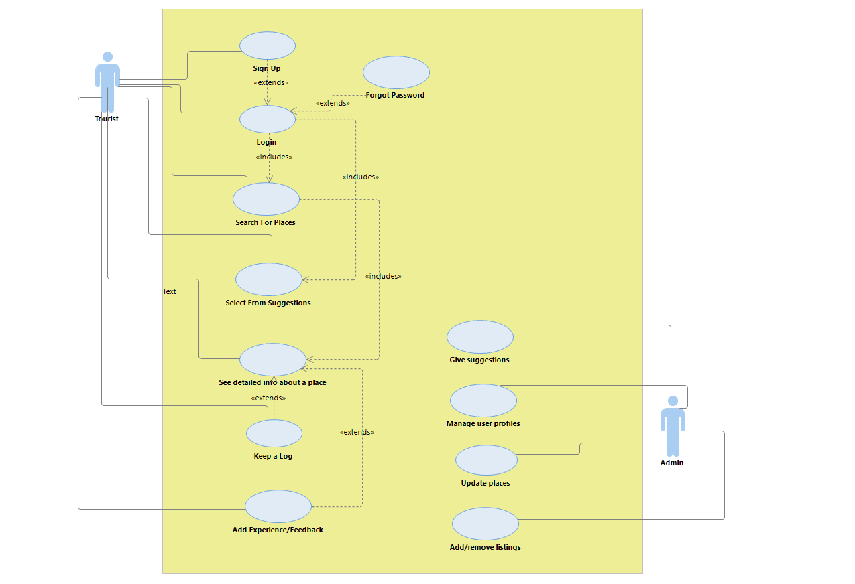

|  |  |
| --- | --- |
| 1.Use case title | Add experience/feedback |
| 2. Abbreviated title | feedback |
| 3. Use case id | 3 |
| 4. Actors | user(tourist) |
| 5. Description  With this facility, users can share their experience of the places they visited with other users coming to the website, by writing their reviews and rating the places.  For example- A user can rate 4 stars to a place and write review as ‘good’. | |
| 5.1. Preconditions  The user must be logged in to the website | |
| 5.2. Task sequence   1. User can write their experience or review. 2. User can give rating to the place in terms of stars. | |
| 5.3. Post conditions   1. User can edit their review. 2. User can delete the review. | |
| 6. Modification History Date: 03/04/2024 | |
| 7. Author: Akshit Tiwari | |

|  |  |
| --- | --- |
| 1.Use case title | See from suggestions |
| 2. Abbreviated title | see suggestions |
| 3. Use case id | 2 |
| 4. Actors | user(tourist) |
| 5. Description  With this facility, users can see and know about good places to visit from the suggestions given by the website.  For example- A user can see suggestions for Cafes like Ricca Cafe | |
| 5.1. Preconditions  The user must be logged in to the website | |
| 5.2. Task sequence   1. Suggestions page will be shown by the system. 2. You can select category from suggestions. 3. The system will show details about the place by clicking on that place name button. | |
| 5.3. Post conditions   1. User can view his selected place. 2. User can still go for another search. | |
| 6. Modification History Date: 03/04/2024 | |
| 7. Author: Divyanshu Kumar | |

|  |  |
| --- | --- |
| 1.Use case title | Search For Places |
| 2. Abbreviated title | Search places |
| 3. Use case id | 1 |
| 4. Actors | user(tourist) |
| 5. Description  With this facility, users can view and search for places they want to visit. For example- search for Jaggi’s restaurant | |
| 5.1. Preconditions  The user must be logged in to the website | |
| 5.2. Task sequence   1. Search screen will be shown by the system. 2. Enter the name of the place. 3. The system will show search results by clicking the search button. | |
| 5.3. Post conditions   1. User can view his desired results. 2. User can go for another search. | |
| 6. Modification History Date: 03/04/2024 | |
| 7. Author: Namrah Sharma | |

|  |  |
| --- | --- |
| 1.Use case title | Manage User Profile |
| 2. Abbreviated title | Manage profiles |
| 3. Use case id | 4 |
| 4. Actors | Admin |
| 5. Description  With this facility, the admin can see and manage all the profiles of the users who have signed up in the website.  For example- A user can see the profile for a user Rishabh. | |
| 5.1. Preconditions  The user must be logged in to the website as an admin. | |
| 5.2. Task sequence  1.The user will sign up to the website, then their database will be made in the website, which the admin can manage. | |
| 5.3. Post conditions   1. Admin can delete the user if some unlawful or ugly behaviour shown. 2. Admin can upgrade the user profile to some plus plan. | |
| 6. Modification History Date: 03/04/2024 | |
| 7. Author: Akshit Tiwari | |

**2.1.2 Use Case Template**

|  |  |
| --- | --- |
| 1.Use case title | Update places |
| 2. Abbreviated title | update |
| 3. Use case id | 5 |
| 4. Actors | Admin |
| 5. Description  With this facility, the admin can update and make changes in the data of the places mentioned in the website  For example- Admin can change the open timings of a place from 9 am to 10 am. | |
| 5.1. Preconditions  The user must be logged in to the website as an admin. | |
| 5.2. Task sequence   1. Admin will get details from the place about the update details and then update the data accordingly | |
| 5.3. Post conditions  1.Admin can change the details again in the future if required.  2.Admin can change any other place also | |
| 6. Modification History Date: 03/04/2024 | |
| 7. Author: Prajwol Regmi | |

|  |  |
| --- | --- |
| 1.Use case title | Add/remove listings |
| 2. Abbreviated title | Add/remove |
| 3. Use case id | 6 |
| 4. Actors | Admin |
| 5. Description  With this facility, the admin can add or delete the places listings from the website  For example- Admin can delete Starbuck’s data if it is now closed. | |
| 5.1. Preconditions  The user must be logged in to the website as an admin. | |
| 5.2. Task sequence   1. Admin will get details from the place about the closing or opening details of existing or new places then add or remove the data accordingly | |
| 5.3. Post conditions  1.Admin can change the details again in the future if required. | |
| 6. Modification History Date: 03/04/2024 | |
| 7. Author: Divyanshu Kumar | |

* 1. **Activity Diagram and Swimlane Diagram**

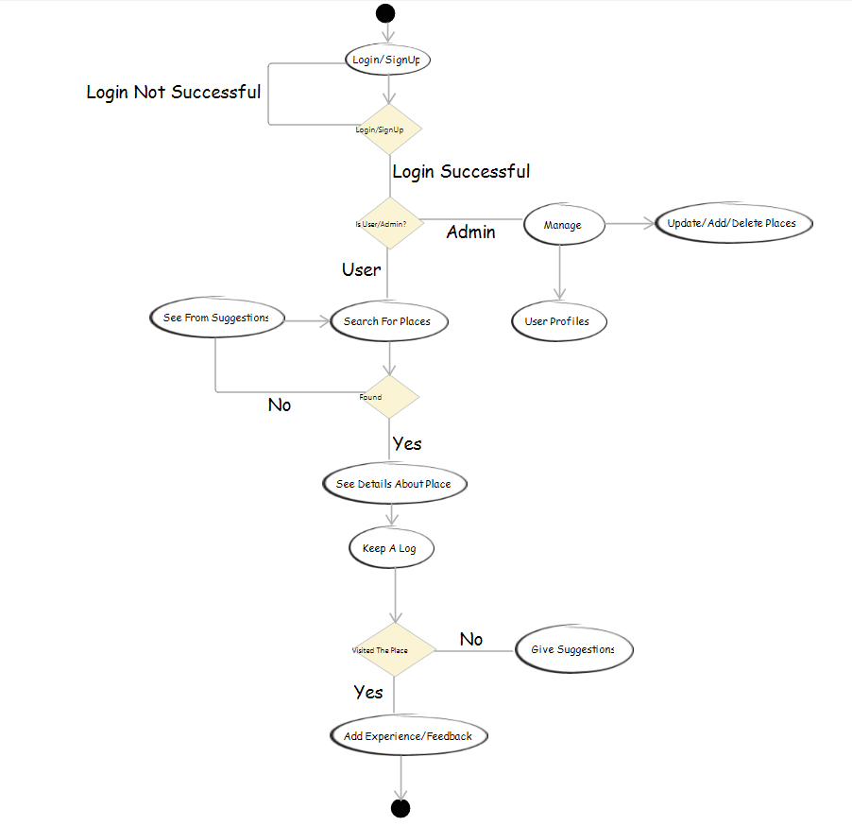

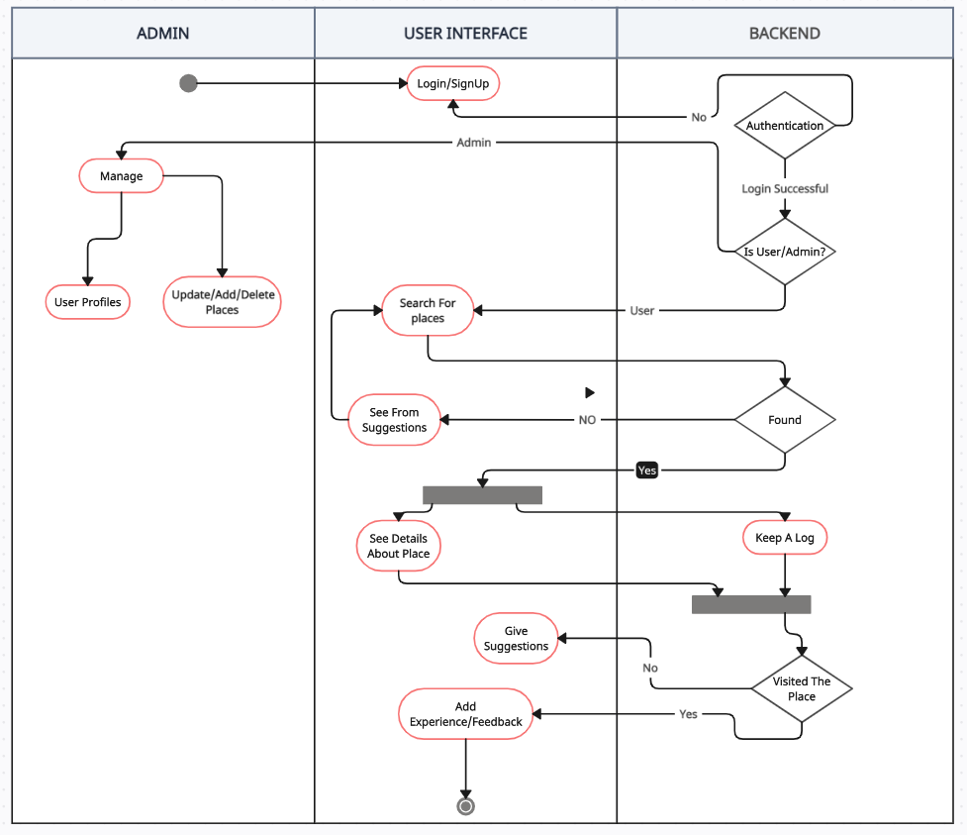

,+

* 1. **Class Diagram**

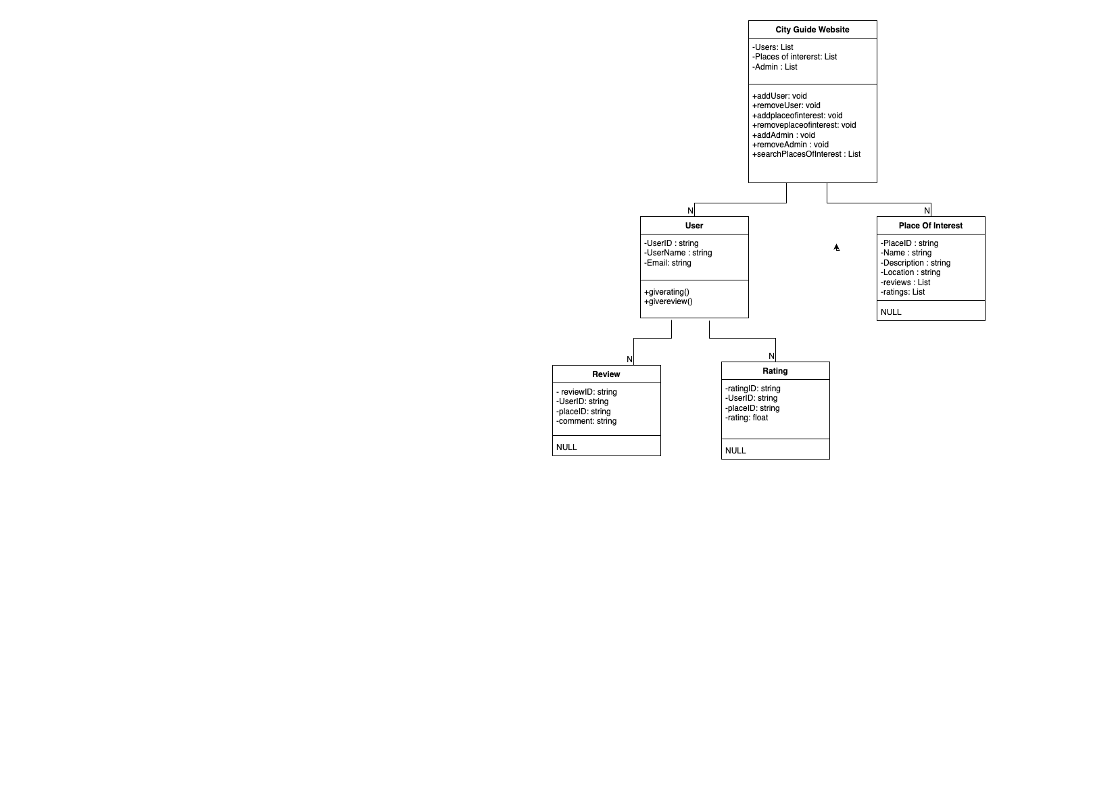

* 1. **Data Flow Diagrams**

2.4.1 DFD Level 0

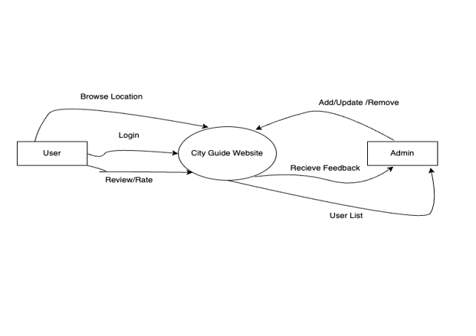

2.4.2 DFD Level 1

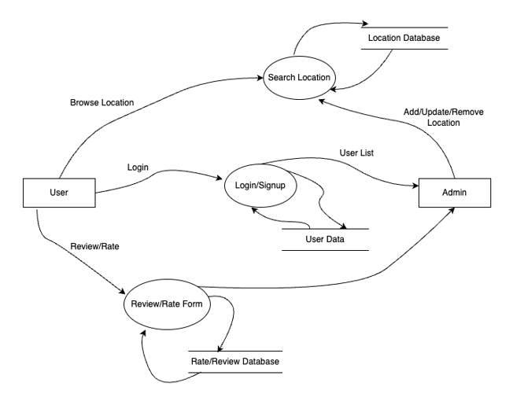

* + 1. DFD Level 2

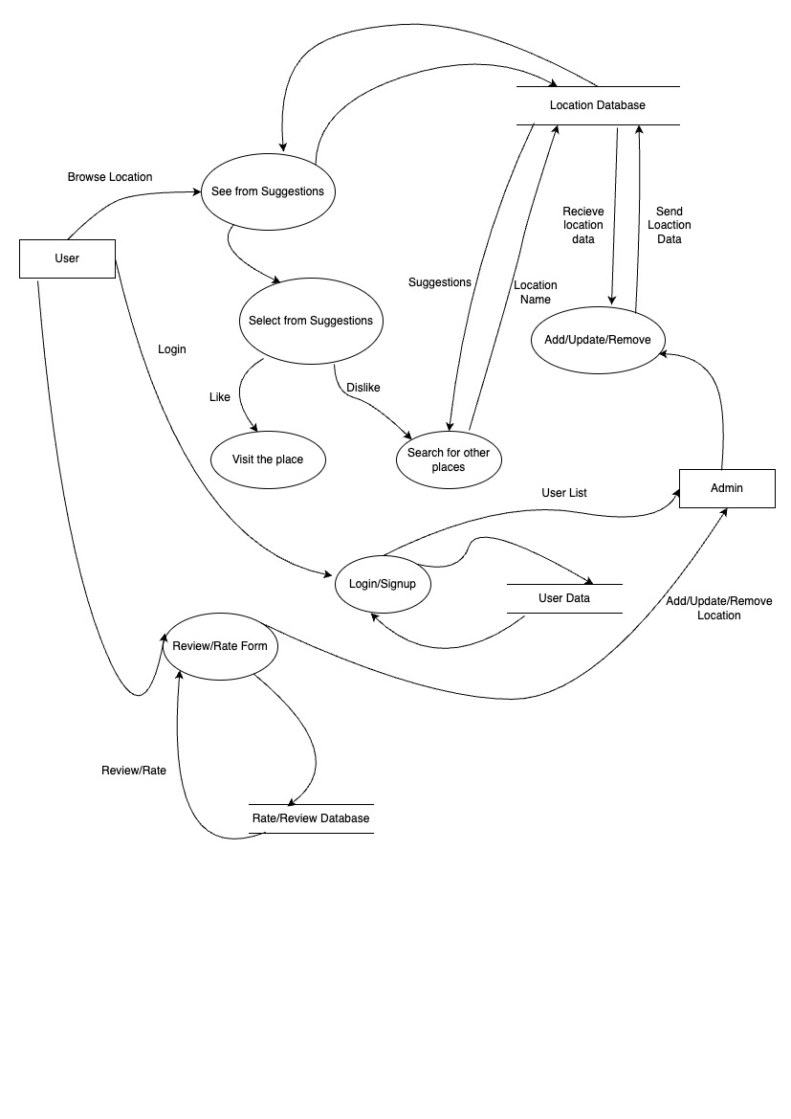

**2.5 Software Requirement Specification in IEEE Format**

**Guide Website: Destination Dose**

1. **Introduction**

City Guide Website is a web-based platform designed to provide users with comprehensive information about the city of Patiala, including places to eat, places to visit, and activities available in the city. To access the information, users are required to log in, ensuring personalized recommendations and seamless navigation.

1. **Scope**

City Guide Website aims to serve both locals and tourists by offering detailed insights into the various attractions, dining options, and activities within Patiala. The website will include interactive maps, user reviews, and recommendations to enhance the user experience.

1. **Functional Requirements**
   1. **User Authentication**

Requirement 1: Users must register and log in to access the features of the website.

Requirement 2: User authentication should be secure and protect sensitive information.

* 1. **Places to Eat**

Requirement 3: Users can browse a categorized list of restaurants, cafes, and eateries in Patiala.

Requirement 4: Each restaurant listing should include details such as cuisine type, address, contact information, and user ratings.

Requirement 5: Users can leave reviews and ratings for restaurants after logging in.

* 1. **Places to Visit.**

Requirement 6: Users can explore popular landmarks, historical sites, and tourist attractions in Patiala.

Requirement 7: Each attraction listing should include details such as opening hours, entry fees, location, and user ratings.

Requirement 8: Users can save attractions to their favorites list for future reference.

* 1. **Activities Available.**

Requirement 9: Users can discover various activities and events happening in Patiala, such as festivals, concerts, and sports events.

Requirement 10: Each activity listing should include details such as date, time and venue.

* 1. **Provide Feedback / Review**

Requirement 12: User can share their experience on places they have been to through feedback form and provide rating and review of the place. 3.6 User Profile Management.

Requirement 13: Users can update their profile information, including name, email, and password. Requirement 14: Users can view their saved favorites, reviews, and ratings in their profile dashboard.

1. **Non-functional Requirements**
   1. **Performance**

Requirement 14: The website should load quickly to provide a seamless user experience.

Requirement 15: The system should handle concurrent user requests efficiently without significant latency.

* 1. **Security**

Requirement 16: User authentication and data transmission should be encrypted to ensure data privacy.

Requirement 17: The website should implement measures to prevent unauthorized access and protect against common web vulnerabilities.

* 1. **Usability**

Requirement 18: The user interface should be intuitive and easy to navigate for users of all levels.

Requirement 19: The website should be responsive and accessible on various devices, including desktops, tablets, and smartphones.

1. **Constraints**

The website's information will be limited to Patiala city only. The accuracy and relevance of information depend on regular updates and user contributions.

1. **Assumptions**

Users have access to a stable internet connection to use the website effectively. Users are willing to provide necessary personal information for registration and profile management.

1. **Glossary**

User: Any individual accessing the Destination Dose Website.

Attractions: Landmarks, historical sites, and tourist spots in Patiala.

Activities: Events, festivals, and recreational opportunities available in Patiala.

1. **Conclusion**

Destination Dose aims to provide a comprehensive platform for users to explore, discover, and engage with the city's diverse offerings. By incorporating user authentication and personalized features, the website seeks to enhance user experience and promote tourism in Patiala.

* 1. **User Stories and Story Cards**

|  |  |
| --- | --- |
| **FRONT** | **BACK** |
| **Story:**  As a user, I want to log in to the city guide website so that I can access personalized features and save my preferences. | **Acceptance Criteria:**  1. Users can register for a new account or log in with existing credentials.  2. The login process is secure and protects user information.  3. Upon successful login, users are redirected to their personalized dashboard.  4. Incorrect login attempts are handled gracefully with clear error messages. |

|  |  |
| --- | --- |
| **FRONT** | **BACK** |
| **Story:**  As a user, I want to receive search suggestions and easily find places of interest so that I can explore the city efficiently and discover new attractions. | **Acceptance Criteria:**  1. The search bar provides autocomplete suggestions based on user input.  2. Users can click on a suggestion or continue typing to refine their search query.  3. Search results are displayed in a clear and organized manner, with relevant details for each place.  4. The system prioritizes popular and highly rated places in search results. |

|  |  |
| --- | --- |
| **FRONT** | **BACK** |
| **Story:**  As a user, I want to leave feedback and ratings for places I've visited so that I can share my experiences with others and help improve the city guide. | **Acceptance Criteria:**  1. Users can leave written feedback and assign ratings (e.g., stars) for attractions, restaurants, and other places.  2. The feedback form is easy to access and intuitive to use, encouraging user engagement. 3. Reviews and ratings are displayed prominently on the website alongside place listings.  4. Users can edit or delete their feedback if needed. |